Lesson Plan - Intermediate
Date : Aug 10th, 2022
Meeting : 16th
Topic : Review Meeting
Objective : Review Meeting (All materials)

Cycle 1 (30 Minutes)
Presentation (10 Minutes)
- T and Ss review about Simple Present, Yes/NO questions, WH Questions, adverb of frequency, will and be going to
Practice (10 Minutes)
- T asks Ss to give comments about the previous review
- T asks Ss to complete exercise about present tense, will, and be going to
- T asks Ss to create sentences based on provided verbs from
https://eslgames.com/webapps/randomverb.html
Production (10 Minutes)
- T asks the Ss to share their daily routines, what they are going to do in the near future

Cycle 2 (30 Minutes)
Presentation (10 Minutes)
- T and Ss review about Past Tense, regular and irregular verbs, and adjectives
Practice (10 Minutes)
- Ss give comments about the previous review
- Ss finish exercise about past tense
Production (10 Minutes)
- T asks Ss to speak about their activity in the past week

Cycle 3 (30 Minutes)
Presentation (10 Minutes)
- T reviews about present perfect tense, adverb before adjectives, and conjunctions
Practice (10 Minutes)
- T asks Ss to give comments about the review
- T reviews exercise on Interchange Book
Production (10 Minutes)
- T requires Ss to describe their friends
- T asks Ss to have conversation session about what they have learned in the intermediate class

Tutor of Homie English

Muhammad Ichsan Al Hafiz, S.Pd
Mengetahui
Director of Homie English

Robi Kurniawan, S.Pd, MA, TESOL

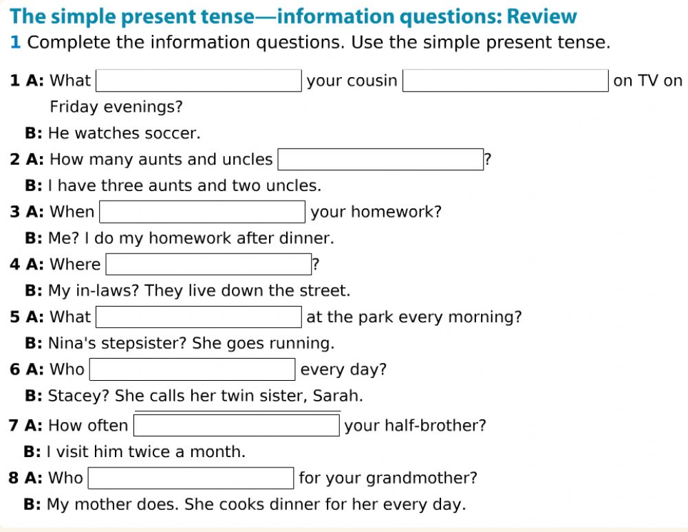
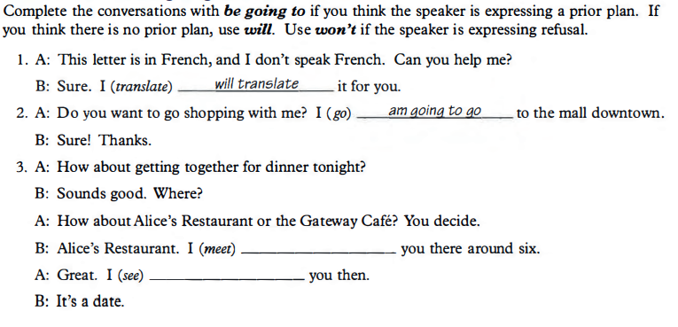
Will and be going to
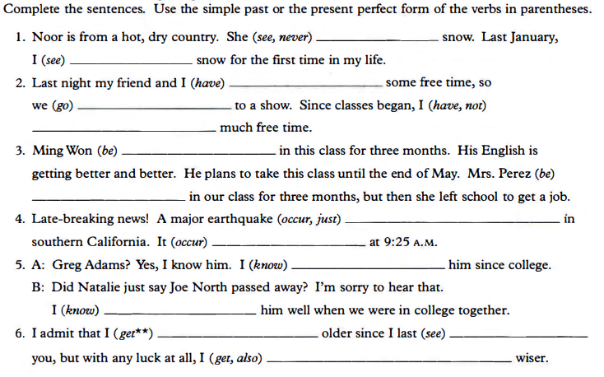
Present perfect vs past tense

