**Lesson Plan - Intermediate**

Date : Aug 10th, 2022

Meeting : 16th

Topic : Review Meeting

Objective : Review Meeting (All materials)

**Cycle 1 (30 Minutes)**

Presentation (10 Minutes)

* T and Ss review about Simple Present, Yes/NO questions, WH Questions, adverb of frequency, will and be going to

Practice (10 Minutes)

* T asks Ss to give comments about the previous review
* T asks Ss to complete exercise about present tense, will, and be going to
* T asks Ss to create sentences based on provided verbs from

<https://eslgames.com/webapps/randomverb.html>

Production (10 Minutes)

* T asks the Ss to share their daily routines, what they are going to do in the near future

**Cycle 2 (30 Minutes)**

Presentation (10 Minutes)

* T and Ss review about Past Tense, regular and irregular verbs, and adjectives

Practice (10 Minutes)

* Ss give comments about the previous review
* Ss finish exercise about past tense­

Production (10 Minutes)

* T asks Ss to speak about their activity in the past week

**Cycle 3 (30 Minutes)**

Presentation (10 Minutes)

* T reviews about present perfect tense, adverb before adjectives, and conjunctions

Practice (10 Minutes)

* T asks Ss to give comments about the review
* T reviews exercise on Interchange Book

Production (10 Minutes)

* T requires Ss to describe their friends
* T asks Ss to have conversation session about what they have learned in the intermediate class

**Tutor of Homie English**

**Muhammad Ichsan Al Hafiz, S.Pd**

**Mengetahui**

**Director of Homie English**

**Robi Kurniawan, S.Pd, MA, TESOL**

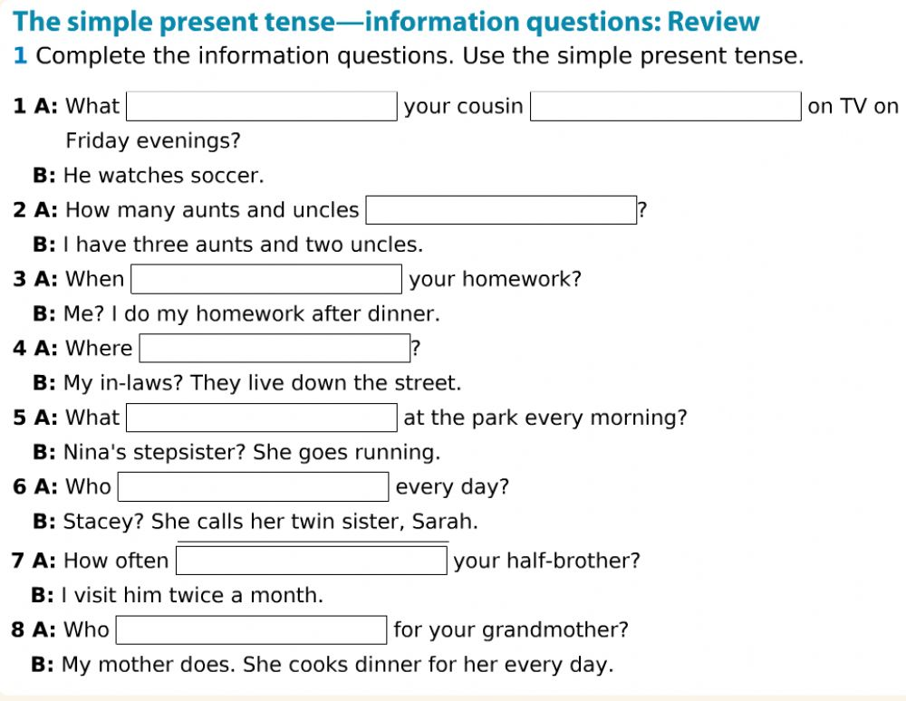

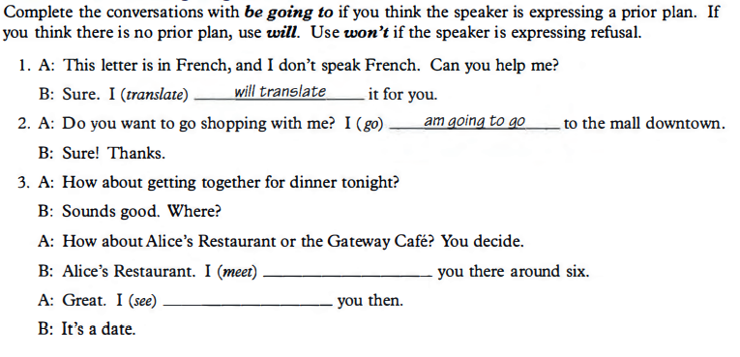**Will and be going to**

**Present perfect vs past tense**