Lesson Plan – Basic
Date : Oct 16th, 2022
Meeting : 12th
Topic : What did you do yesterday?
Objective : Students are able to speak and respond statements and questions related to past activity

Cycle 1 (30 Minutes)
Presentation (10 Minutes)
- T asks Ss if they are happy today
- T asks Ss what makes them happy/not happy
- T reviews previous material about verbal & nominal sentences in past simple
Practice (10 Minutes)
- T asks Ss to complete exercise 1 (supplementary worksheet)
Production (10 Minutes)
- Ss play irregular bingo

Cycle 2 (30 Minutes)
Presentation (10 Minutes)
- T explains WH questions using Simple Past Tense
Practice (10 Minutes)
- https://agendaweb.org/verbs/past-simple.html
Production (10 Minutes)
- S tells one of his holiday activities in the past

Cycle 3 (30 Minutes)
Presentation (10 Minutes)
- T explains more about WH questions using Simple Past Tense
- T explains the use of “used to”
Practice (10 Minutes)
- Ss listen to the song
Production (10 Minutes)
- Ss play Past Simple Boardgame

Tutor of Homie English

Muhammad Ichsan Al Hafiz, S.Pd
Mengetahui
Director of Homie English

Robi Kurniawan, S.Pd, MA, TESOL

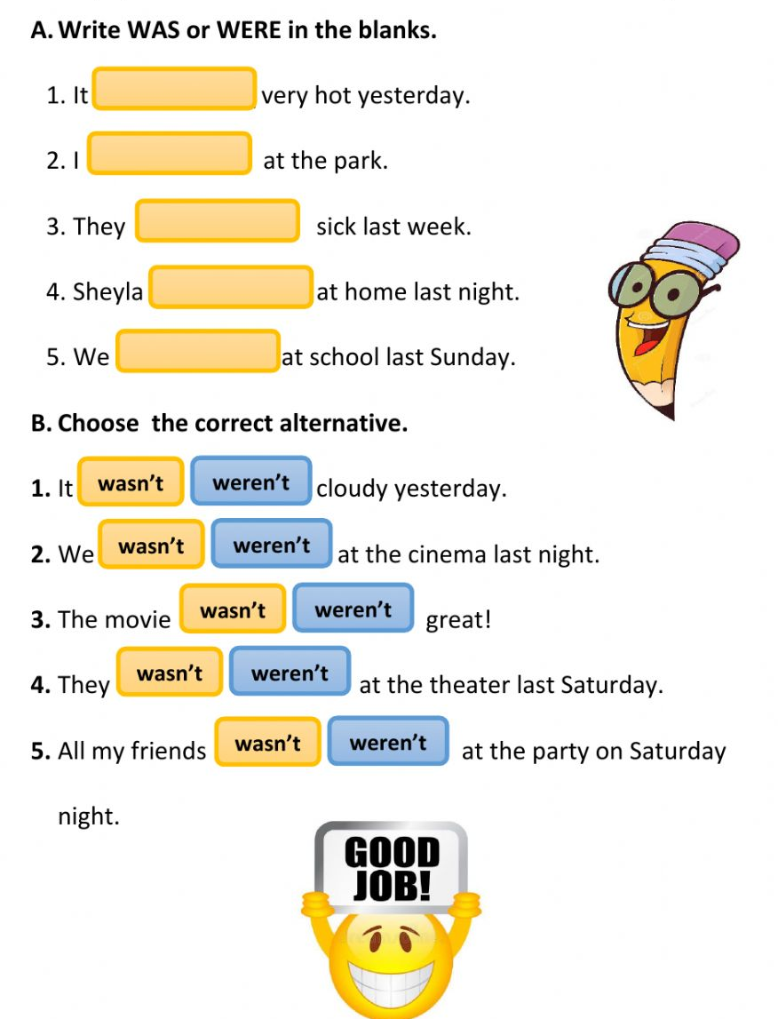
EXERCISE 1
