**Lesson Plan – Basic**

Date : Oct 16th, 2022

Meeting : 12th

Topic : What did you do yesterday?

Objective : Students are able to speak and respond statements and questions related to past activity

**Cycle 1 (30 Minutes)**

Presentation (10 Minutes)

* T asks Ss if they are happy today
* T asks Ss what makes them happy/not happy
* T reviews previous material about verbal & nominal sentences in past simple

Practice (10 Minutes)

* T asks Ss to complete exercise 1 (supplementary worksheet)

Production (10 Minutes)

* Ss play irregular bingo

**Cycle 2 (30 Minutes)**

Presentation (10 Minutes)

* T explains WH questions using Simple Past Tense

Practice (10 Minutes)

* <https://agendaweb.org/verbs/past-simple.html>

Production (10 Minutes)

* S tells one of his holiday activities in the past

**Cycle 3 (30 Minutes)**

Presentation (10 Minutes)

* T explains more about WH questions using Simple Past Tense
* T explains the use of “used to”

Practice (10 Minutes)

* Ss listen to the song

Production (10 Minutes)

* Ss play Past Simple Boardgame

**Tutor of Homie English**

**Muhammad Ichsan Al Hafiz, S.Pd**

**Mengetahui**

**Director of Homie English**

**Robi Kurniawan, S.Pd, MA, TESOL**

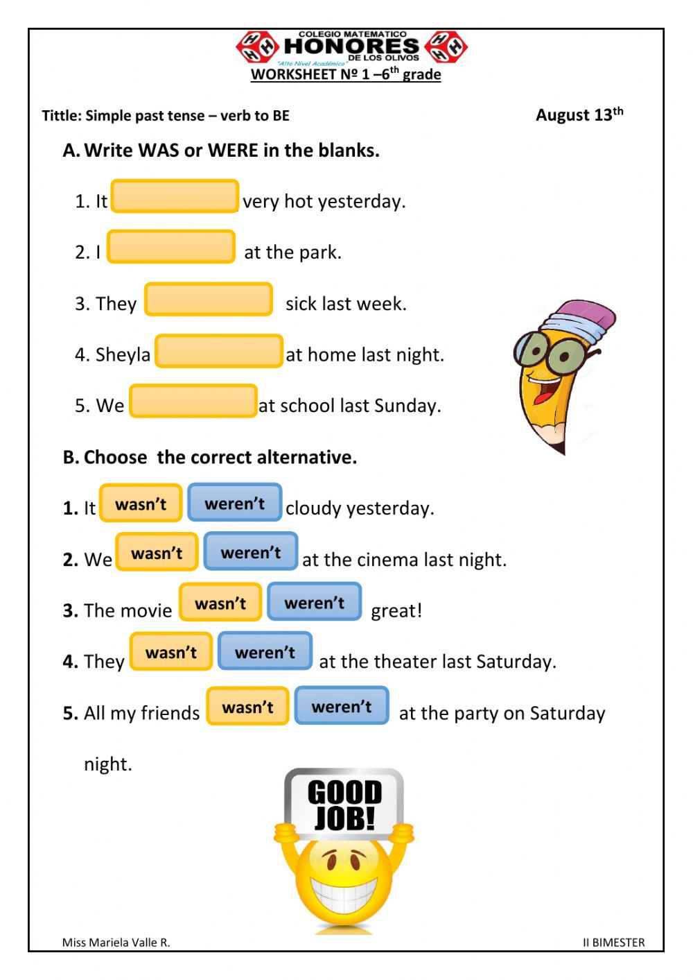**EXERCISE 1**

