Lesson Plan – Basic
Date : Sep 11th, 2022.
Meeting : 4th
Topic : What do you do every day?
Objective : Students are able to speak and respond statements and questions by using simple present tense (simple present tense)

Cycle 1 (30 Minutes)
Presentation (10 Minutes)
- Warming-up
- https://www.education.com/game/dino-photoshoot-subject-verb-agreement/
- https://www.abcya.com/games/nouns_and_verbs
- T reviews previous material
- T explains some singular verb (s/es) and adverb of frequency
Practice (10 Minutes)
- T asks the S to tell his/her someone’s daily activity in the morning, in the afternoon, or at night by showing daily activity card
Production (10 Minutes)
- T asks S to tell his/her family daily activity on weekend

Cycle 2 (30 Minutes)
Presentation (10 Minutes)
- T explains the use of auxiliary verb do and does
Practice (10 Minutes)
- T asks S to do supplementary material about plural or singular verb
- https://www.liveworksheets.com/worksheets/en/English_Language_Arts_(ELA)/Verbs/Singular_and_Plural_Verbs_tv1689872uy
Production (10 Minutes)
- T asks S to retell T’s daily activities to practice singular verb

Cycle 3 (30 Minutes)
Presentation (10 Minutes)
- T explains about simple present tense for nominal sentence by giving examples.
Practice (10 Minutes)
- T asks S to do supplementary material
- https://agendaweb.org/verbs/to-be-exercises.html
- Listening (Don’t give up) on page 9
Production (10 minutes)
- T asks S to share his/her personality guided by 1000 conversation questions on page 107

Tutor of Homie English

Muhammad Ichsan Al Hafiz, S.Pd
Mengetahui
Director of Homie English

Robi Kurniawan, S.Pd, MA, TESOL

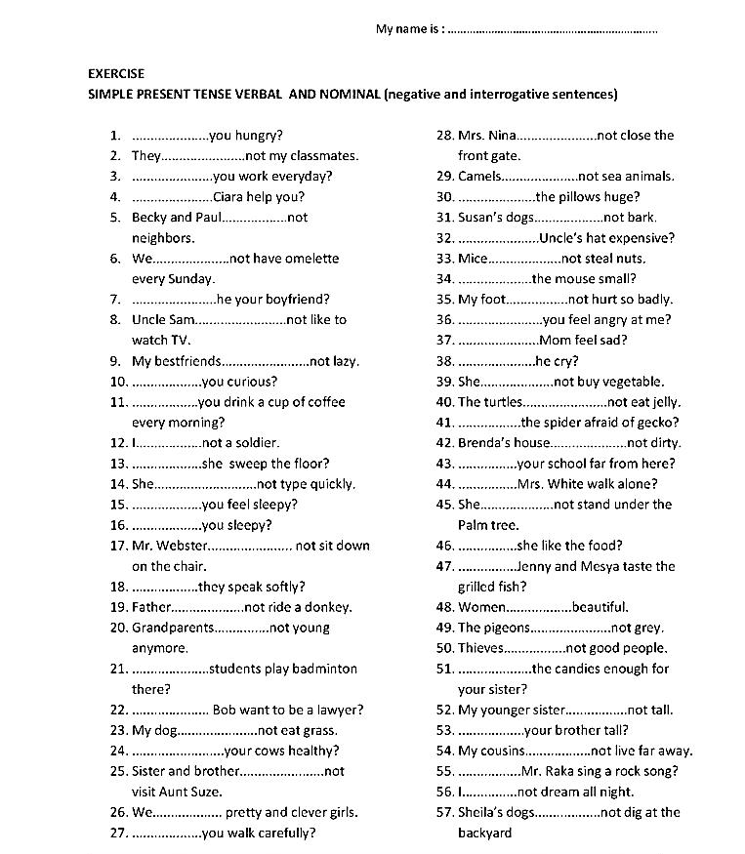
EXERCISE

