**Lesson Plan – Basic**

Date : Sep 11th, 2022.

Meeting : 4th

Topic : What do you do every day?

Objective : Students are able to speak and respond statements and questions by using simple present tense (simple present tense)

**Cycle 1 (30 Minutes)**

Presentation (10 Minutes)

* Warming-up
* <https://www.education.com/game/dino-photoshoot-subject-verb-agreement/>
* <https://www.abcya.com/games/nouns_and_verbs>
* T reviews previous material
* T explains some singular verb (s/es) and adverb of frequency

Practice (10 Minutes)

* T asks the S to tell his/her someone’s daily activity in the morning, in the afternoon, or at night by showing daily activity card

Production (10 Minutes)

* T asks S to tell his/her family daily activity on weekend

**Cycle 2 (30 Minutes)**

Presentation (10 Minutes)

* T explains the use of auxiliary verb *do* and *does*

Practice (10 Minutes)

* T asks S to do supplementary material about plural or singular verb
* <https://www.liveworksheets.com/worksheets/en/English_Language_Arts_(ELA)/Verbs/Singular_and_Plural_Verbs_tv1689872uy>

Production (10 Minutes)

* T asks S to retell T’s daily activities to practice singular verb

**Cycle 3 (30 Minutes)**

Presentation (10 Minutes)

* T explains about simple present tense for nominal sentence by giving examples.

Practice (10 Minutes)

* T asks S to do supplementary material
* <https://agendaweb.org/verbs/to-be-exercises.html>
* Listening (Don’t give up) on page 9

Production (10 minutes)

* T asks S to share his/her personality guided by 1000 conversation questions on page 107

**Tutor of Homie English**

**Muhammad Ichsan Al Hafiz, S.Pd**

**Mengetahui**

**Director of Homie English**

**Robi Kurniawan, S.Pd, MA, TESOL**

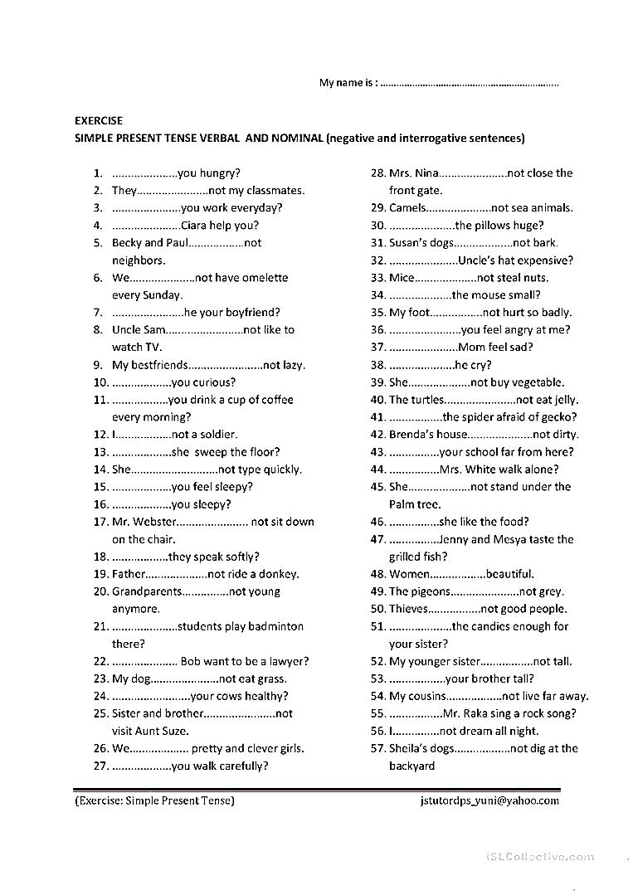**EXERCISE**