**Lesson Plan - Intermediate**

Date : Sep 4th, 2022

Meeting : 2nd

Topic : Where do you come from?

Objective : Students are able to introduce themselves and mention some particular events: family, hobby, future plan (focused on cardinal & ordinal numbers, and pronoun)

**Cycle 1 (30 Minutes)**

Presentation (10 Minutes)

* T explains about pronoun (subject, object, relative adjective, relative pronoun, and reflexive) by giving example.

Practice

* Ss complete online exercise about pronoun
* <https://wordwall.net/resource/36887/pronouns>
* <https://agendaweb.org/grammar/pronouns-mixed.html>

Production (10 Minutes)

* T asks Ss to tell a short story about their family member to practice introduction and pronoun

**Cycle 2 (30 Minutes)**

Presentation (10 Minutes)

* T asks some question related to distance or time (*asking where they live, how many minutes/hours they need to go to . . . )*
* T introduces cardinal numbers in English (*asking what their favorite number is)*

Practice (10 Minutes)

* T invites the Ss to play number game, T shows some number then the Ss should say the number loudly

Production (10 Minutes)

* T asks the Ss to tell when their birthday, age (*family members)*, important dates history of Indonesia.

**Cycle 3 (30 Minutes)**

Presentation (10 Minutes)

* T introduces ordinal numbers in English

Practice (10 Minutes)

* The Ss do the exercise (SP)

Production (10 Minutes)

* T and Ss play number games then practice it together
* T and Ss play “throwing number”

**Tutor of Homie English**

**Muhammad Ichsan Al Hafiz, S.Pd**

**Mengetahui**

**Director of Homie English**

**Robi Kurniawan, S.Pd, MA, TESOL**

EXERCISE 1

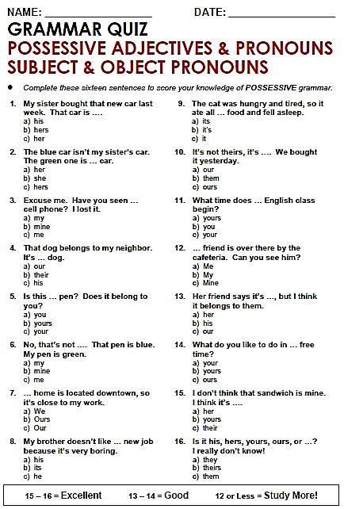

Exercise 2

