Exercise 1
Circle the regular verb!
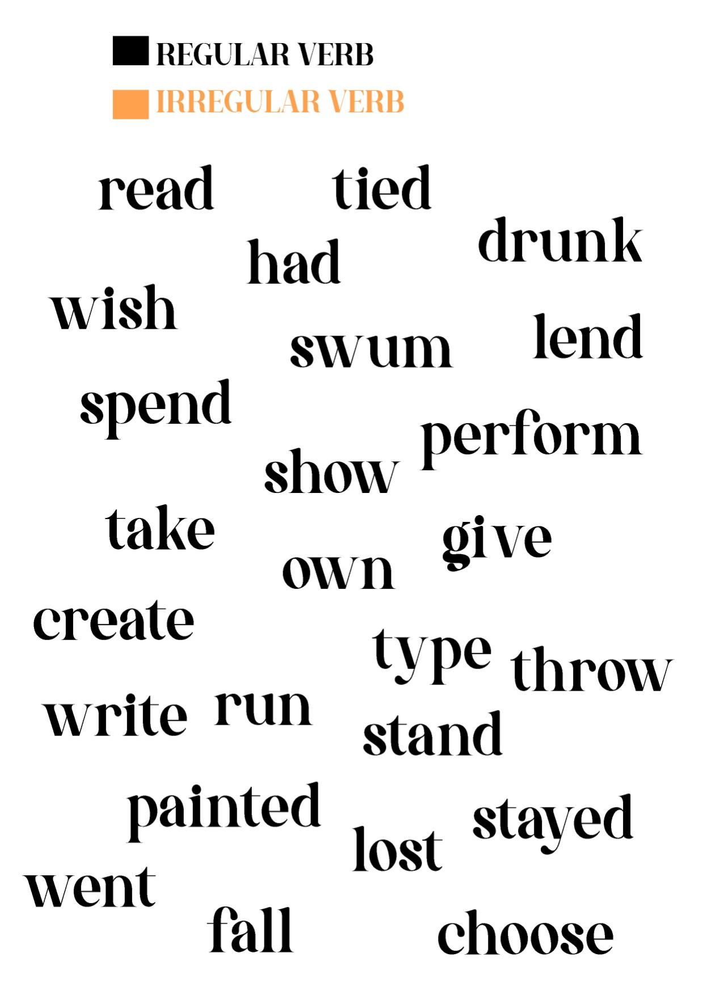

Exercise 2
Complete the table of verb below!

Verb 1 | Verb 2 | Verb 3 | Meaning (Bahasa Indonesia)
stand | stood | stood | berdiri
 |  | cooked
 | flied
sing
 |  |  | memanjat
wake
 | drew
 |  | taken
 |  |  | menanyakan/bertanya
breath
 | mentioned
catch
build
 |  | rung
 | became
 |  |  | melihat
 | color
 |  | said
begin
 |  | met
 | meant
 |  |  | menemukan
write
 | told
apologize
 |  | torn
 | answered
 |  |  | mencuci
throw
 |  |  | meledakkan
 | understood
 |  | had
 |  |  | pergi
travel
 |  | closed

