**Exercise 1**

**Circle the regular verb!**

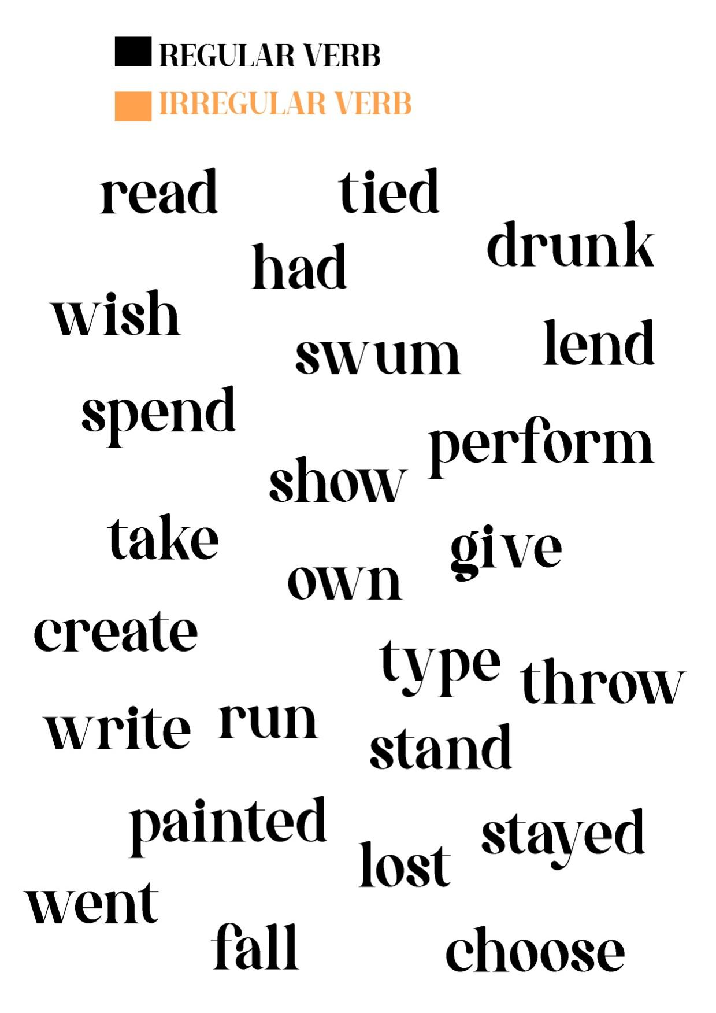

**Exercise 2**

**Complete the table of verb below!**

|  |  |  |  |
| --- | --- | --- | --- |
| **Verb 1** | **Verb 2** | **Verb 3** | **Meaning (Bahasa Indonesia)** |
| stand | stood | stood | berdiri |
|  |  | cooked |  |
|  | flied |  |  |
| sing |  |  |  |
|  |  |  | memanjat |
| wake |  |  |  |
|  | drew |  |  |
|  |  | taken |  |
|  |  |  | menanyakan/bertanya |
| breath |  |  |  |
|  | mentioned |  |  |
| catch |  |  |  |
| build |  |  |  |
|  |  | rung |  |
|  | became |  |  |
|  |  |  | melihat |
|  | color |  |  |
|  |  | said |  |
| begin |  |  |  |
|  |  | met |  |
|  | meant |  |  |
|  |  |  | menemukan |
| write |  |  |  |
|  | told |  |  |
| apologize |  |  |  |
|  |  | torn |  |
|  | answered |  |  |
|  |  |  | mencuci |
| throw |  |  |  |
|  |  |  | meledakkan |
|  | understood |  |  |
|  |  | had |  |
|  |  |  | pergi |
| travel |  |  |  |
|  |  | closed |  |