WH-questions
Speaking cards




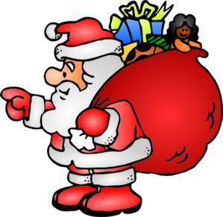

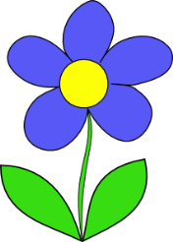
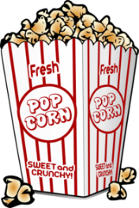
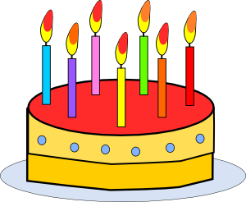
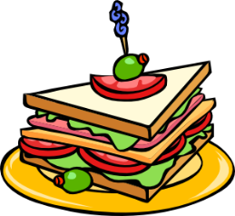



FOOD
- What is your favorite dish?
- Why do you like it?
- When do you eat it?
- How often do you cook it?

HOBBY
- What are your hobbies?
- Why do you like them?
- When did you start them?

FRIENDS
- Who is your best friend?
- How often do you see him/her?
- Where does he/she live?
- How does he/she help you?

ANIMALS
- What is your favorite animal?
- Why do you like it?
- Where does it live?
- What does it eat and drink?

BIRTHDAY
- When is your birthday?
- How do you celebrate it?
- What presents do you like?
- How many friends do you
usually invite?

MOVIES
- What is your favorite movie?
- Why do you like it?
- When did you see it?
- Who are the actors there?

SEASON
- Which season do you like the most?
- Why do you like it?
- What do you do in this season?
- Where do you spend it?

SCHOOL
- What is your favorite subject?
- Why do you like it?
- How often do you study it?

MUSIC
- What is your favorite music?
- Why do you like it?
- When do you listen to it?
- Who is your favorite singer?

HOLIDAYS
- What is your favorite holiday?
- Why do you like it?
- What do you eat and drink
on this day?
- Where do you spend it?

