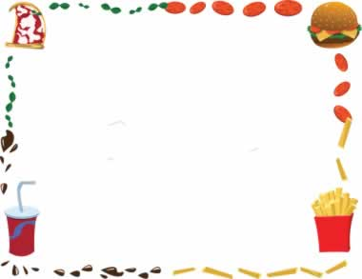
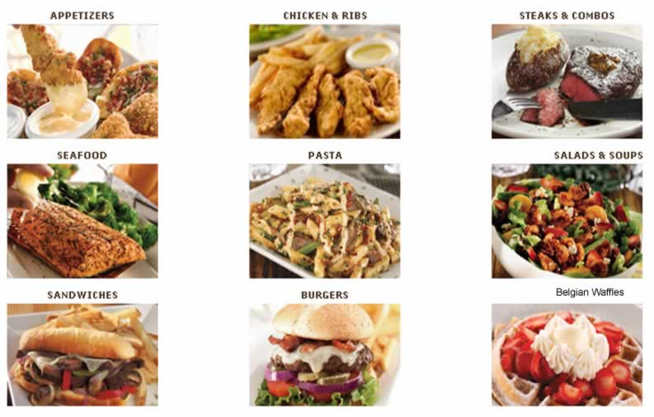
Gloria and Andreia’s Diner
Appetizers

Onion rings $2.25

Squid rings $ 7.50

Mini burgers (4) $ 6.49

Nachos & ribs $ 6.00

chicken wings $5.75

Caesar salad $3.99

clam chowder $4.50

Entrées

meat Spaghetti $11.95

seafood noodle $15.95

NY steak $12.89

Desserts

Belgian waffles $1.50

toppings each $1.00

whipping cream $1.00

blueberry pie $2.35

sandwiches

chicken& onion $ 3.15

Cheeseburger $2.59

triple deck $5.29

tasty veggie $3.19

Drinks

soda light $0.99
soda diet $0.90
reg. soda $0.70
tea $0.68
coffee $0.85

